EXP2-2 Experimental plan P19
Authors: Ruikai Chen (2021304212) Yue Fei (2021304175) Ruopu Feng (2021304249) Xubo Fan (2021304250) Shouman Liu (2021304234)
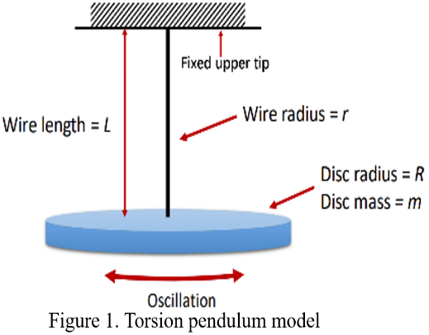
This study will center on determining the shear modulusof metal and polymer wires, which can be quantified using the formula: . Where E is Young’s modulus, v is Poisson’s ratio. For experiment principle, in torsional pendulum model, the twisting wire oscillate in simple harmonic motion. In this procedure, thread is treated as a cylinder, with the assumption that the sector undergoes a shear deformation resulting in an angular rotation relative to the initial sector, directly proportional to the cylinder's height. Hence, the shear modulus can be derived from the subsequent formula:where L is the length of the wire and r is the wire radius, m is the mass of a disc with radius R, and T is the period of oscillation.
Experiment design
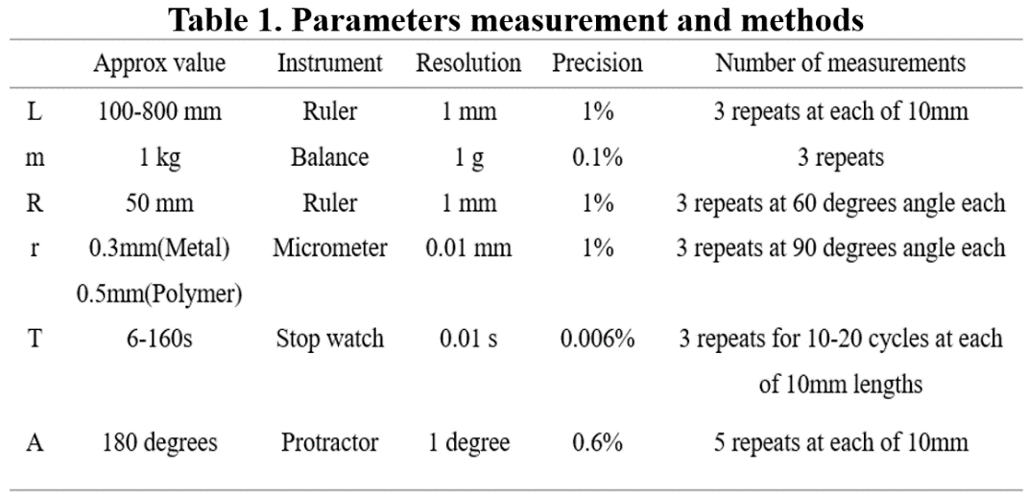
The procedures of experiment are: 1. Obtain the experimental equipment after ensuring the safety. 2. Commence the experiment after calibrating the measuring instruments and recording necessary parameters (Table 1). 3. Go through the torsional pendulum experiment and document the radius of thread r, torsion period T, and amplitude A with various lengths L situation. 4. Data processing. Where L, T and A are variable quantities that will change with length or time during experiment. All precisions are less than 1% and significant figures follow the resolution.
For uncertainties, the measurements of T and A exhibit higher levels of uncertainty. Unlike the static measurements of parameters such as L, M, R, r, the determination of A and T necessitates dynamic assessments. This requirement compels manual judgments on the completion of a vibration cycle by the disk and the manual timing of the vibration duration. Such manual interventions introduce inherent inaccuracies into the process.
Result estimation
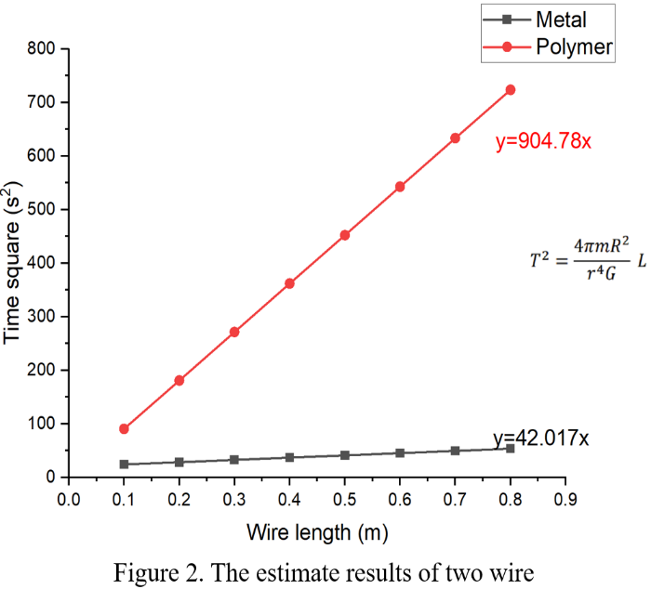
The shear modulus of both metal and polymer wires can be calculated based on the given Young's modulus and Poisson's ratio, which are then applied in the linear equation of L and T² to derive the experimental predictive outcomes. (Figure 2)
The visual data indicates that the total values of T fall within the small range of approximately 3-50 s, suggesting a significant number of vibration cycles within the experiment. Moreover, the comparison of the vertical axis and slopes of the two inclined lines reveals that the polymer thread requires more time to complete a vibration cycle compared to the metal counterpart, resulting in a lower frequency of vibrations over a given duration and reflecting a notably smaller shear modulus. In contrast, the metal wire exhibits a considerably diminutive vertical axis, suggesting the necessity of employing a longer wire during experimentation to ensure the uncertainty is small.

